**WebSite URL**: <http://ec2-52-42-246-129.us-west-2.compute.amazonaws.com/>

**Github Repository**: <https://github.com/msr5zb/webHomework2>

**Objective**: I set out to make a Responsive Photography Website that was clean-cut. I decided to take this on because my Sister-in-law was wondering if I’d be able to make her a site, or at least a template for her photography.

**Things To be Learned:**

-How to implement PopUp Menus.

-How to Create a Fully Responsive Image Slider.

-How to Create a Fully Responsive Site for PC, Tablet, and Mobile

-Emailing Forms

**Sources Used:**

<https://jquery.com/> - For Most Things

<http://dev.vast.com/jquery-popup-overlay/> - For The PopUps

<http://getbootstrap.com/> - For The Responsiveness

<http://responsiveslides.com/> - For The Slider

**What I Ended Up Implementing:**

I’ve implemented normal Sliders before, however a Responsive Slider was a bit tricky to implement. I ended up finding an excellet resource, from <http://responsiveslides.com/> that helped me out quite a lot!

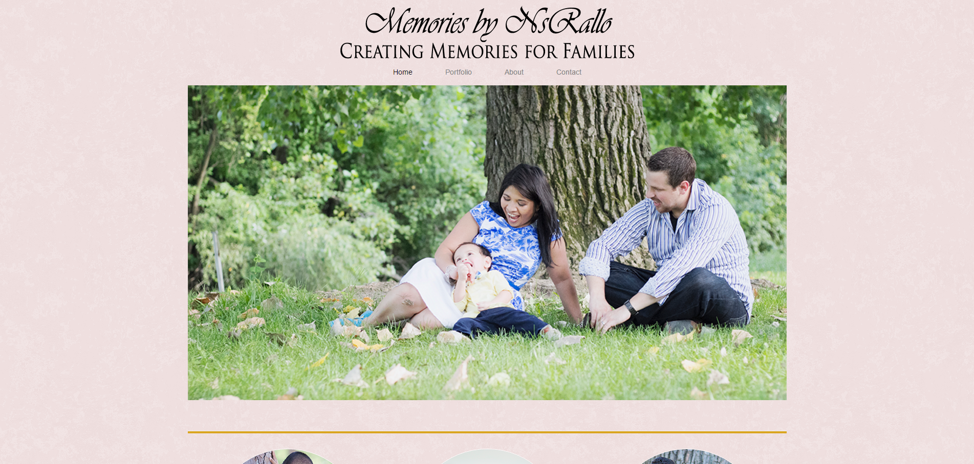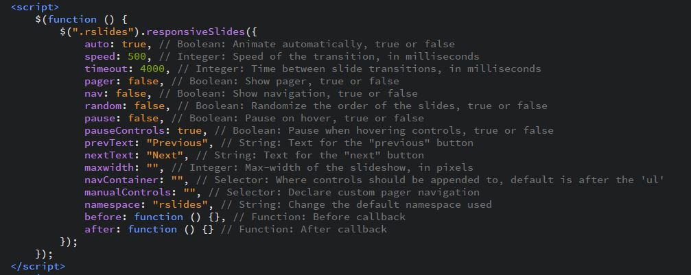

The HTML part of the Slider was easy, and they provided most of the jQuery lib that was necessary. Styling the CSS and little things wasn’t too bad. Overall, was a good resource to discover! Will definitely reuse and recommend!

The PopUps Were also tricky at first to implement. I implemented code based off the <http://dev.vast.com/jquery-popup-overlay/> library.

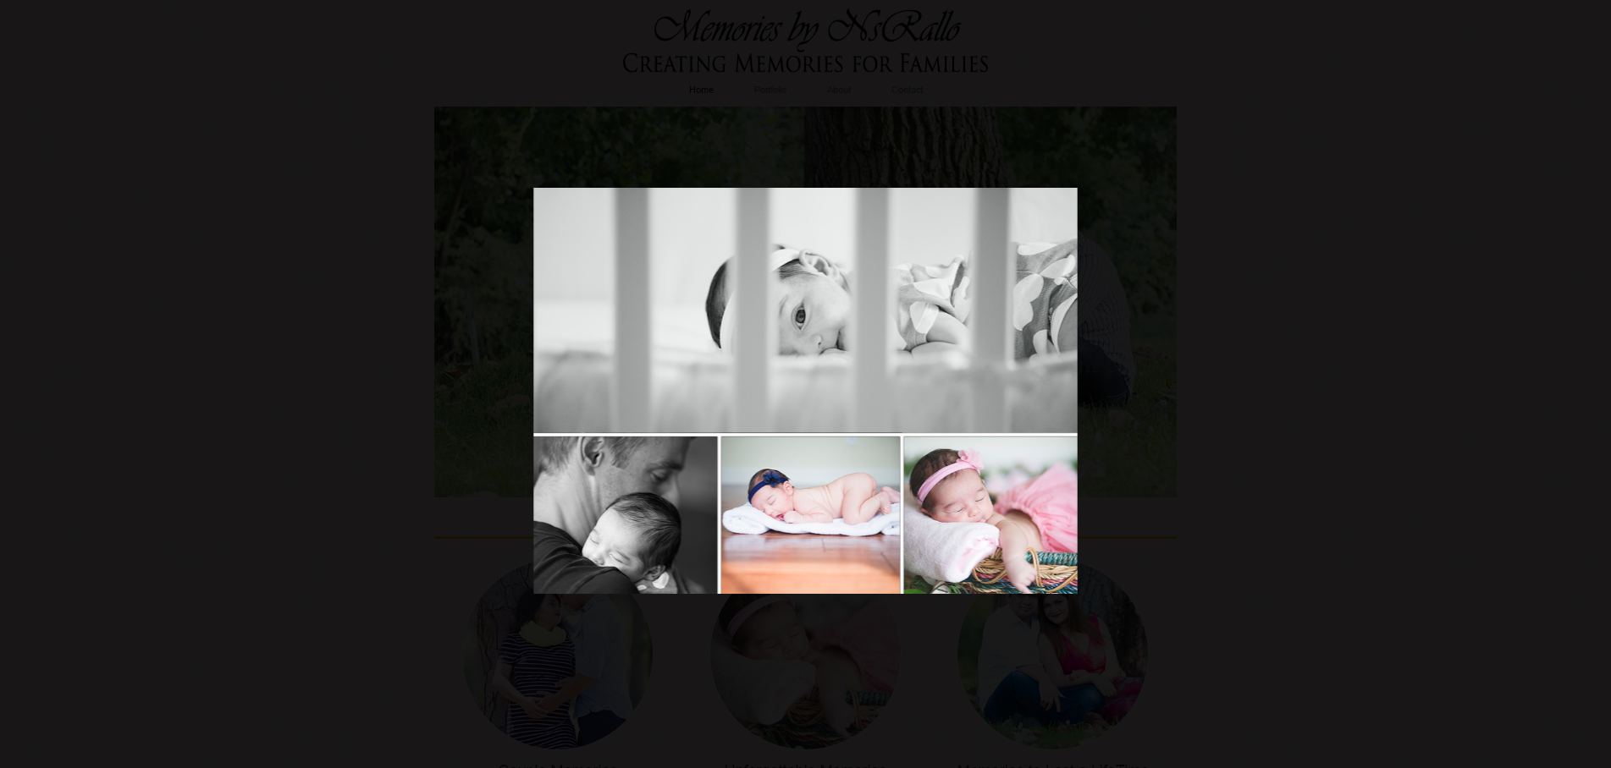

As for the Code, what we needed from me was to learn the logic and implement it. How their popup script works is that they look for a div with the class of parsed string “idName_open” and ‘idName_close” and use that to grab another div of id idName. These open and close the div respectively.

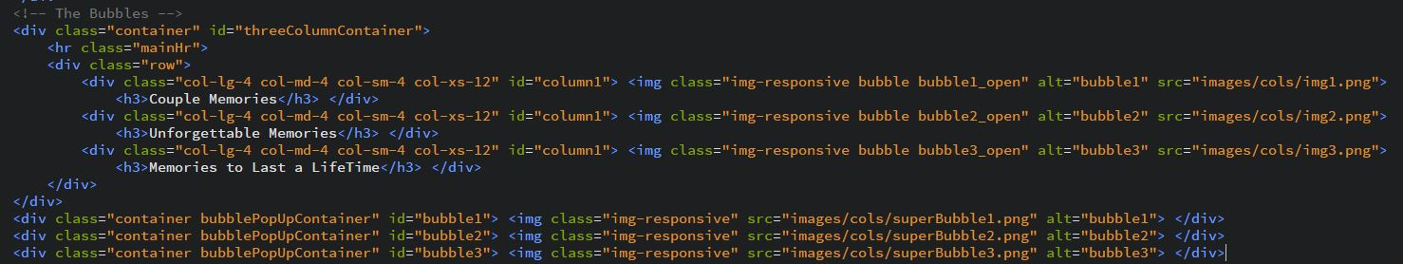

As for the Styling for the PopUps and Background, an API was provided and I implemented as followed:

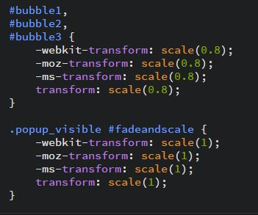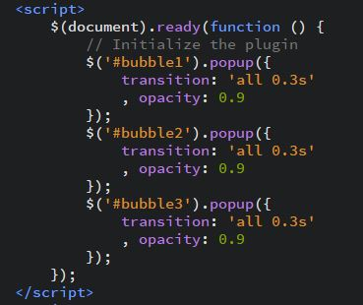

As for Responsiveness, I used Bootstrap’s libraries.

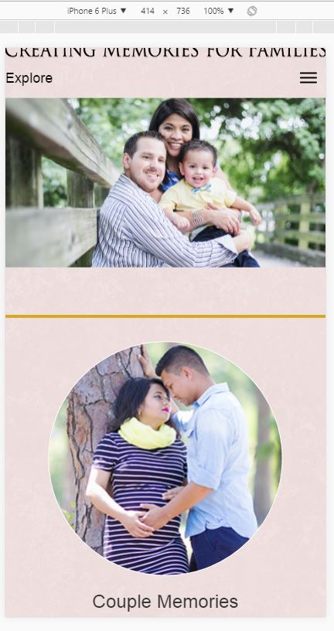

These included Rows, Containers, Container-Fluids, col-lg-x… and so on.

Finally Was the Contact Form. This Uses jQuery, Ajax, as well as PHP to work. Which means, I had to set up PHP in our AWS server. This was a Template Bootstrap Form, so it was pretty easy to implement as well.

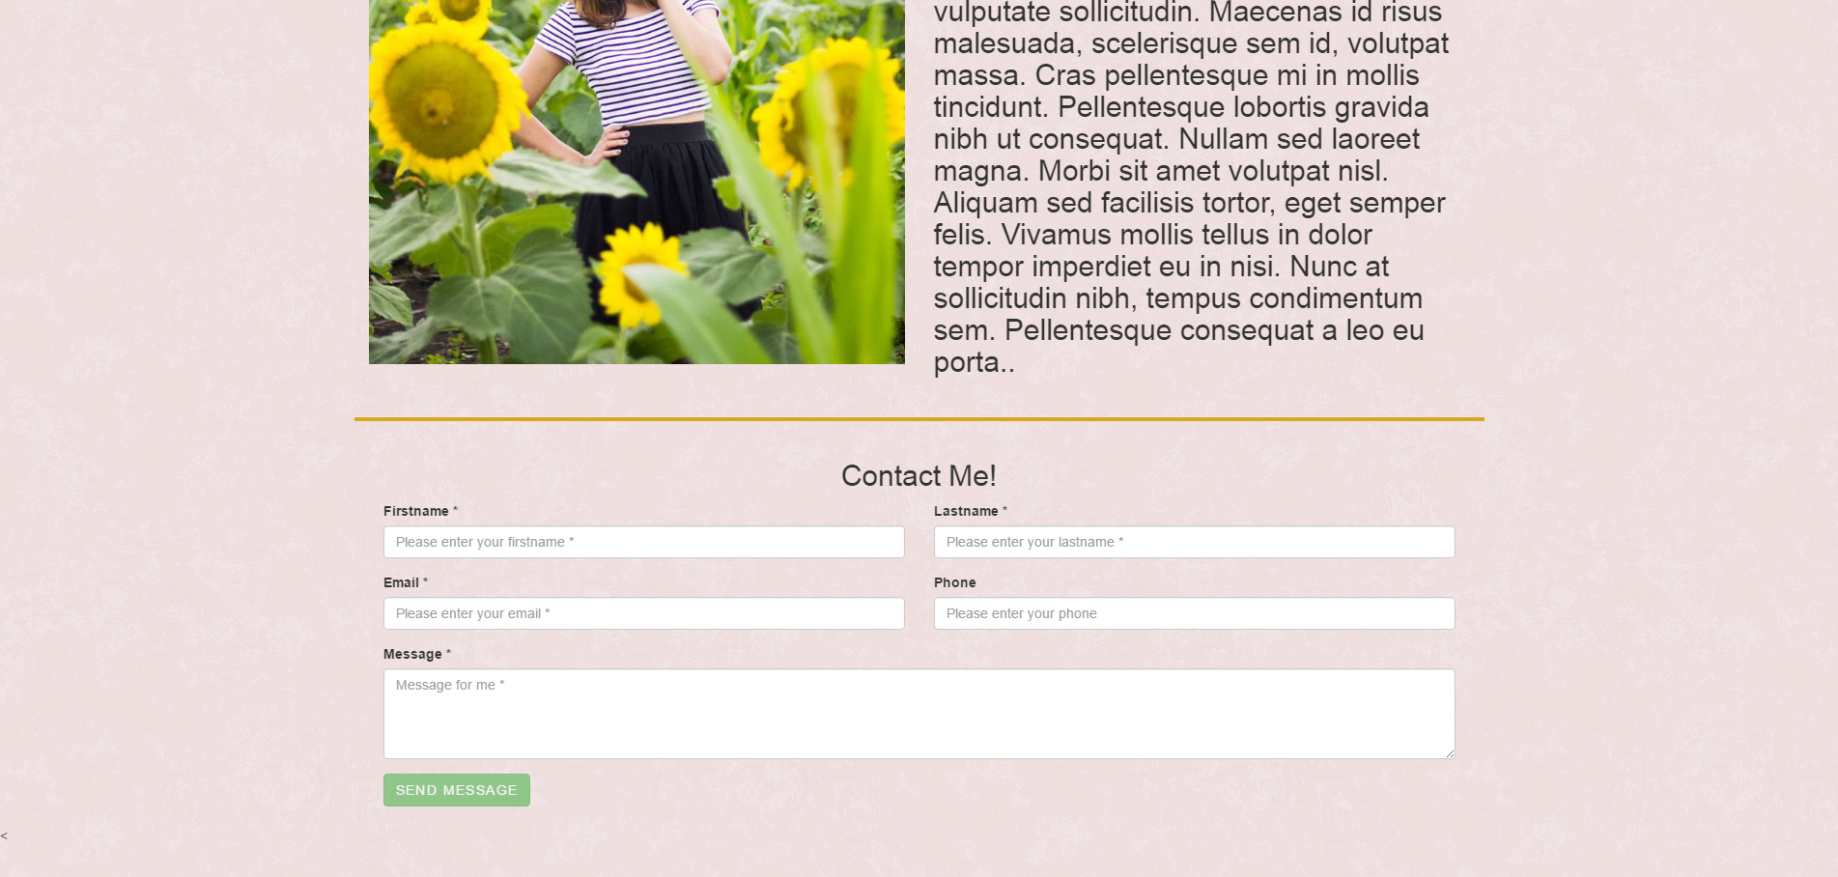

It seems to work all in order, the PHP responses works well, however when I checked to see if the email was sent I believe it got lost. I tried setting up the PHP.ini file to match what was in the documentation, <http://php.net/manual/en/mail.configuration.php>, however it did no good. I believe it’s the send_mail path that is messing things up though.

Along with the Above, I implemented some smoothscrolling and sweet Nav Effects:



I really enjoyed exploring this project. Not only was I able to learn how to use Responsive Sliders, PopUps, BS Forms Controls, and a bunch of Responsive Design Frames, I was able to make a nice template for my Sister to use. Even though getting the forms to use PHP correctly was a bit tough, and the emails get lost, I still am satisfied with what I accomplished! Overall, was a very nice Assignment.

